- Go to the Nustar Master HEASARC Browse Page
- Put the name of the celestial body you’re searching about in the Query Terms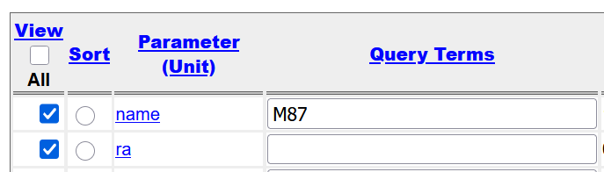
- Scroll down and hit ‘start search’
- You get all the observations. Some might be broken or corrupted for whatever reason; that’s fine. Select some observations. (Earlier it didn’t show me any of the SLEW observation mode ones, I don’t know what I did different this time, or if that’s important. If we want the SLEW observations I’ll go back and download them but for now i only have SCIENCE mode ones)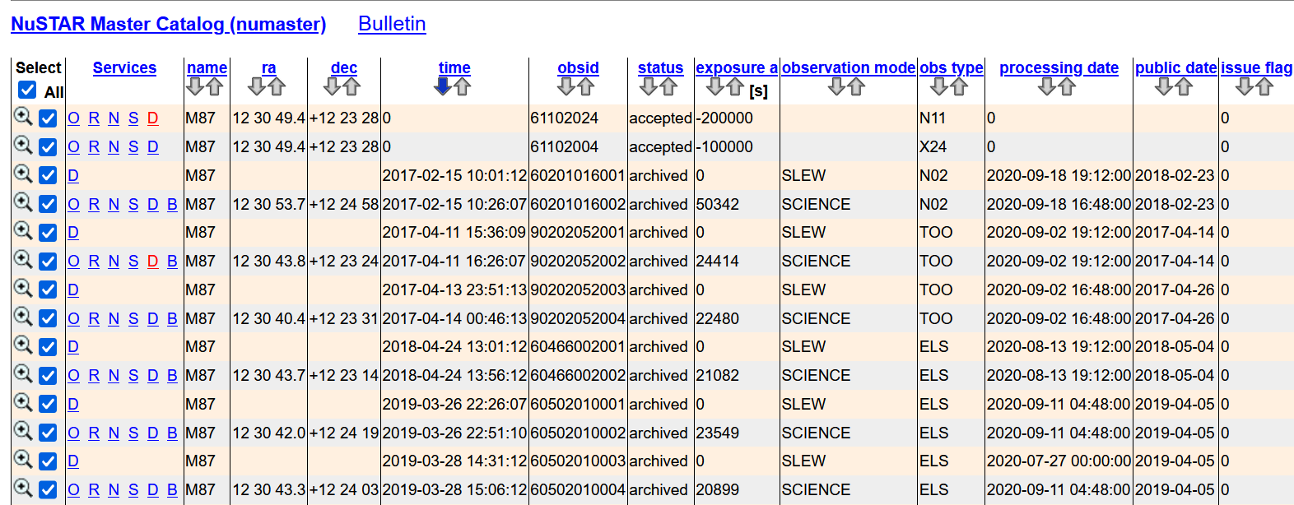
- Scroll to the bottom; you only need to check ‘Unfiltered and Cleaned Data’ for the data. Quicklook contains their image plots, which might be useful for debugging, so I have those too. 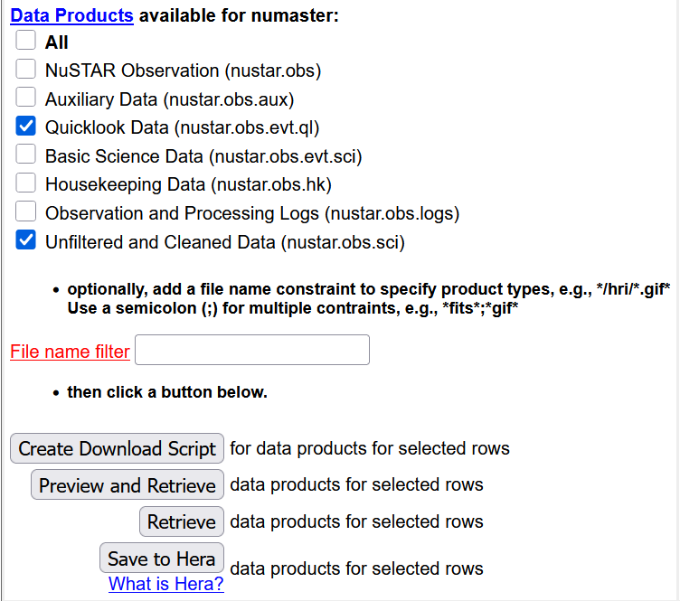
- Hit ‘Retrieve’. It’ll almost certainly yell at you for downloading too much so go back and uncheck them until you can download a batch (Or use the download script but I don’t wanna figure that out rn)
- Congrats you have a .tar file! You can open this with 7zip.
- So far it seems we only need the nu[observation#]A01_cl.evt and B01_cl.evt files, so delete everything else for file space
Voila. Data

